Independent University, Bangladesh 15/06/2014
School of Engineering and Computer Science
Mid-Term Examination, Summer-2014
CSC-203: Data Structure, Full Marks: 30, Time: 60 Minutes

(Answer any TWO from the following THREE questions.)

Student Name: Student ID:

1. | a) | Define the concept of abstract data types (ADT) | 3
 | b) | In two dimensional array A[10][20] each element occupies 4 bytes of memory. If the address of first element X[0][0] is 1024 then what will be the address of the element X[5][8]? | 5
 | c) | Assume the following notation for a node of the Two-way Linked List:  struct DLinkNode  {  int value;  struct DLinkNode *LeftLink;  struct DLinkNode *RightLink;  };  Write an algorithm to add a new node to the linked list. (You may add either before the front node or after the last node.) | 7
2. | a) | Define the following terminology:  - Binary Tree  - Complete Binary Tree  - Full Binary Tree | 3
 | b) | Traverse the given tree using Backward Inorder, Preorder and Post-order traversals.  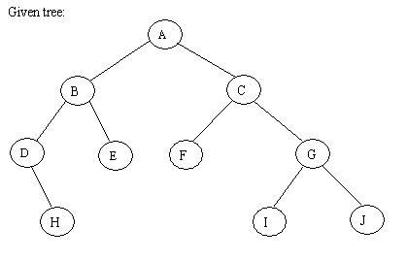 | 6
 | c) | Answer the following questions where a Node is defined to be:  struct Node  {  int value;  struct Node *link;  };  Write a function to insert a node with value=5 before the first occurrence of node with value=7 of a singly linked List.  Hints:  Insert Here  Head | 6
   |  |  | 5 |  |  | 7
3. | a) | A Queue class is defined as follows:  class Queue {  public:  Queue() {// constructor  front = rear = NULL;  counter = 0;  }  ~Queue() {// destructor  double value;  while (!IsEmpty()) Dequeue(value);  }  bool IsEmpty() {  if (counter) return false;  else return true;  }  void Enqueue(double x);  bool Dequeue(double & x);  void DisplayQueue(void);  private:  Node* front; // pointer to front node  Node* rear; // pointer to last node  int counter; // number of elements  };  You need to define the class member functions Enqueue () and Dequeue () using a Linked List based implementation. | 8
 | b) | A compiler usually calculates mathematical expression using postfix notation. However it is first required to convert infix expressions into postfix. An infix expression: A * B + C * D when converted to postfix it becomes A B * C D * +.  Write an algorithm that can convert infix expression into postfix.  Example 1:  Input Sequence: A * B + C * D  Output Sequence: A B * C D * +  Example 2:  Input Sequence: (A * B + C) * D  Output Sequence: A B * C + D * | 7

